Documentation for Elastic search:
1) Setup the things in AWS.
2) Edit elasticsearch.yml file
i) /stack/elasticsearch/config this is the directory of yml file
ii) Set values
network.bind_host: 0.0.0.0

2) To start up elastic search (source: https://bitnami.com/stack/elasticsearch/README.txt)
To start/stop/restart application on Linux or OS X you can use the included
ctlscript.sh utility, as shown below:
./ctlscript.sh (start|stop|restart)
./ctlscript.sh (start|stop|restart) apache
./ctlscript.sh (start|stop|restart) elasticsearch

start - start the service(s)
stop - stop the service(s)
restart - restart or start the service(s)

3) To check start up,
i) Open browser, enter url: http://52.76.90.243:9200/

[REFERENCE: http://developer.couchbase.com/documentation/server/4.0/connectors/elasticsearch-2.1/install-intro.html]

bin/plugin -install transport-couchbase -url http://packages.couchbase.com.s3.amazonaws.com/releases/elastic-search-adapter/2.1.1/elasticsearch-transport-couchbase-2.1.1.zip

After a successful installation, the plug-in installer returns:
DONE Installed transport-couchbase

Updating configurations
Set the user name and password for the plug-in:
echo "couchbase.password: password" >> config/elasticsearch.yml;
echo "couchbase.username: Administrator" >> config/elasticsearch.yml

4) sudo ./ctl.sh elasticsearch restart (If command not works, restart server manually through aws console to apply the modifications)

5) create a cluster in couchbase and create a replication for that elasticsearch index

DELETING DOCUMENTS FROM ELASTICSEARCH
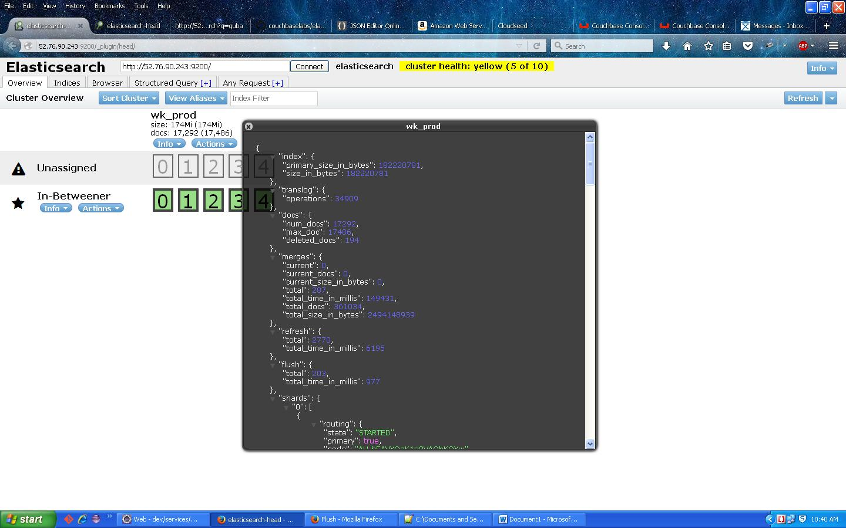
Above picture says details about wk_prod index
Num_docs: 17292
To delete all the docs follow below pic
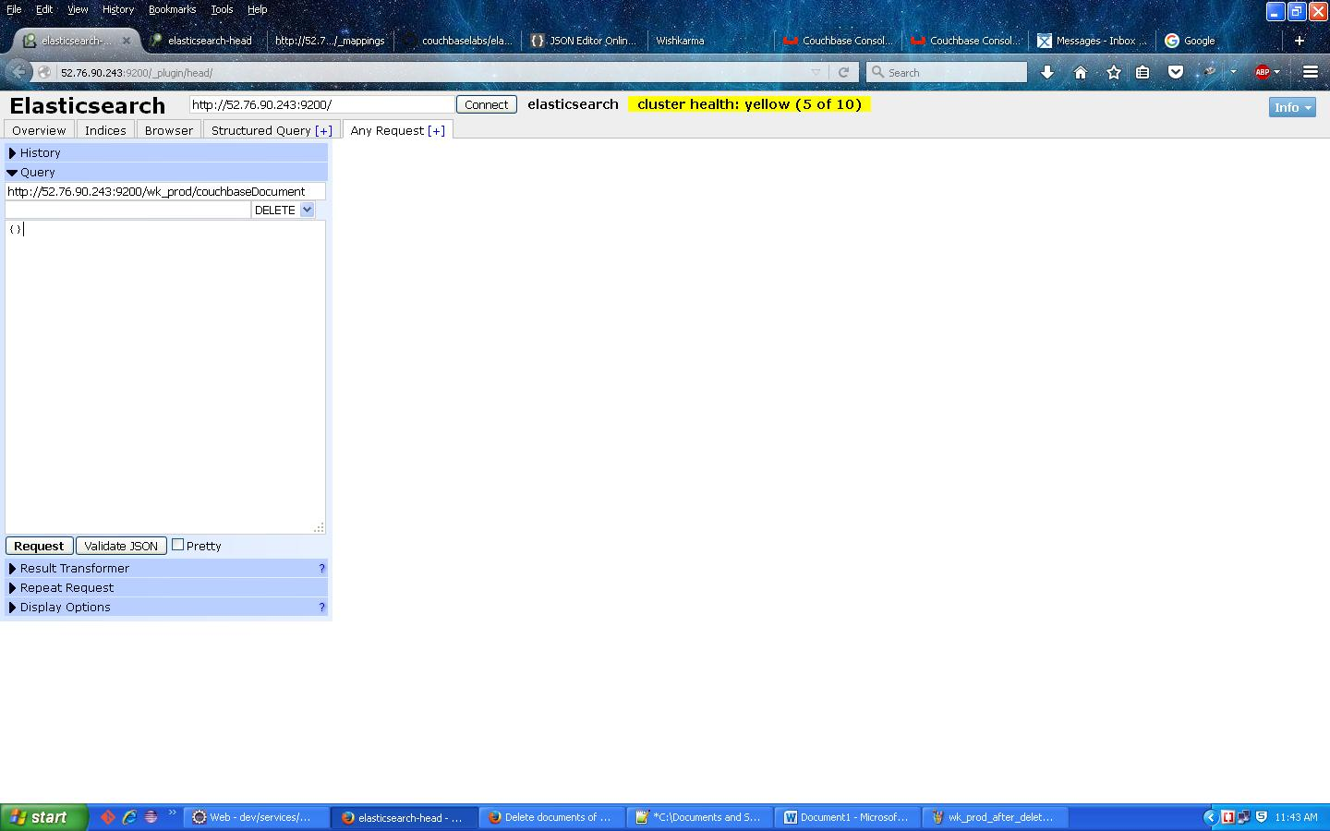
By making DELETE request we can clean the data,
Details about url
http://[the public ip]:[port number]/[index_name]/[document_type]/[doc_id]
So to delete specific document we can use above url pattern, make delete request by placing the values like
Public ip of elastic search is http://52.76.90.243, port number is 9200, index_name is wk_prod, document_type is couchbaseDocument, doc_id is Usereed3d78d9dd-d789d0dd-ddd-d9ddfsd-jty-34f5sa5
If we want to delete all documents, we can also make use of this by mentioning up to document type like http://52.76.90.243:9200/wk_prod/couchbaseDocument this will delete all couchbaseDocuments from elastic search.

To confirm whether the docs are deleted are not
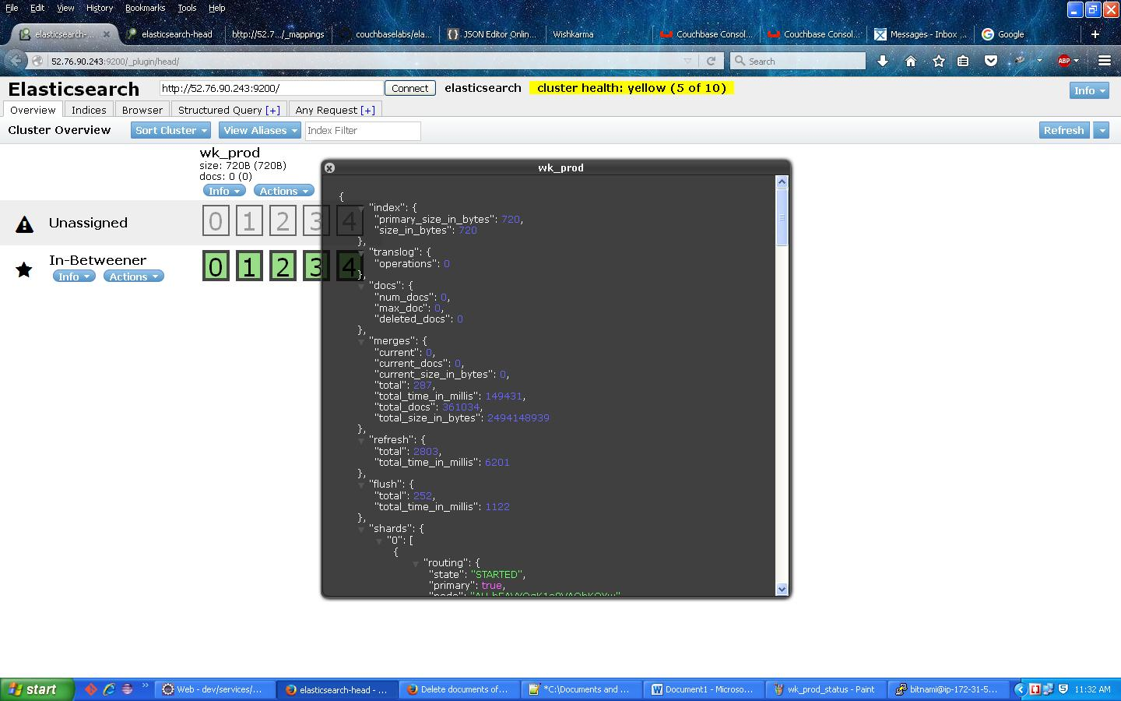

curl -XDELETE "http://localhost:9200/wk_prod/autocomplete/_query" -d '{"query": {"bool": {"must": [{"match_all": {}}]}}}'

curl -XPUT 'http://54.169.175.54:9200/wk_prod_new/' -d '

{

"mappings":{

"_default_" : {

"dynamic":false,

"_source": {

"includes": ["meta.*","author","docType","doc"]

},

"properties" : {

"meta":{

"include_in_all":false,

"type":"object"

},

"doc":{

"dynamic":false,

"properties":{

"about": {"type": "string"},

"author": {"type": "string","index": "not_analyzed"},

"docType": {"type": "string","index": "not_analyzed"},

"mfrProductNo": {"type": "string","index": "not_analyzed"},

"name": {"type": "string","index": "not_analyzed"},

"productType": {"type": "string"},

"recordId":{"type": "string","index": "not_analyzed"},

"$status":{"type": "string"},

"tags":{"type": "string"}

}

}

}

}

}

}'

